./

Learning Report – Automotive Systems and Overview

Course Code: <CODE>



Version Number:

Team Members :

Team No:

Module: Model Based System Engineering

|  |  |  |  |  |  |
| --- | --- | --- | --- | --- | --- |
| **Ver. Rel. No.** | **Release Date** | **Prepared. By** | **Reviewed By** | **Approved By** | **Remarks/Revision Details** |
| 1 | 19-03-2021 | Kopparapu Jyooopa Rani |  |  |  |

**Document History**

# 

Contents

**INTRODUCTION** 4

**RESEARCH** 4

**FEATURES** 4

**SWOT ANALYSIS** 5

**REQUIREMENTS** 5

**DESIGN AND IMPLEMENTION…………………………………………………………………………………………………………………………………..**

**TEST PLAN**

**MOTOR CONTROL ANALYSIS**

Introduction:

Here we have taken 4 systems to analyze they are BLDC with PID controller, PMSM with PID controller, Induction motor with PID controller and PMSM with PWM controller.

1-Brushless DC Motor with PID Controller:

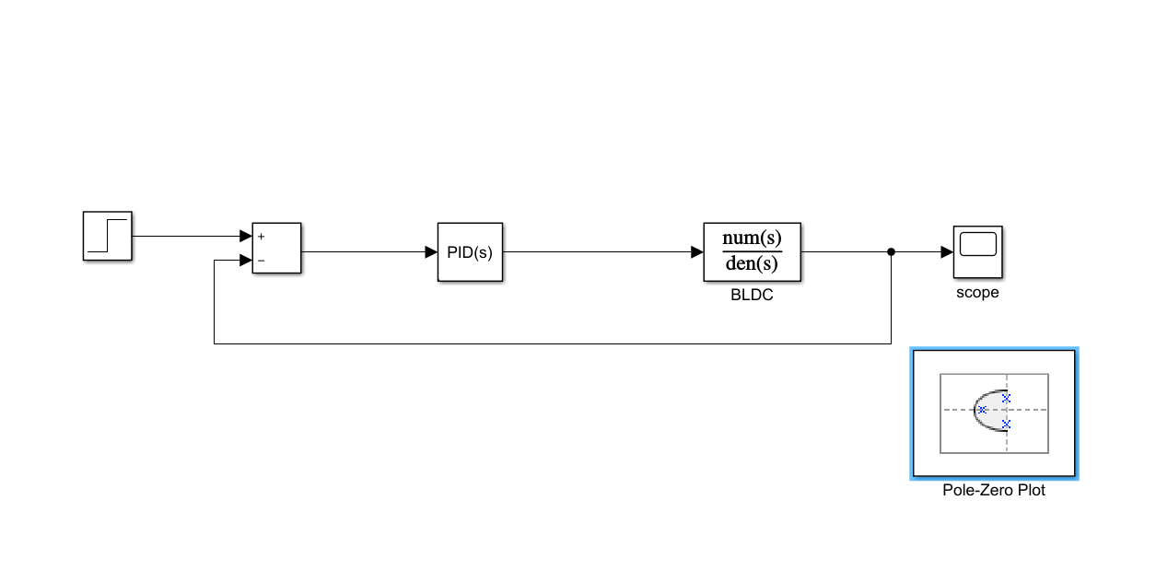

In this system, we will be analyzing the poles and zeros of the system when the PID controller is added to the system.

* We got 1 pair of complex conjugate pole, 1 pole pair on the horizontal axis and 2 zeroes.
* We got 3 poles and 2 zeroes on the left side of the imaginary axis

So, 2 zeroes and 2 poles will nullify their effect and 1 pole will be on the left side so that we can say that system is stable.

Pole-Zero Map and Analysis:

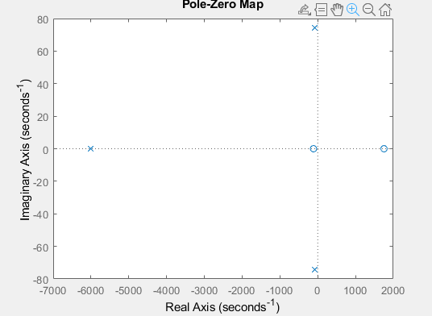

Poles of BLDC system:

1.0e+03 *

-6.0172 + 0.0000i

-0.0882 + 0.0744i

-0.0882 - 0.0744i

Zeroes of BLDC system:

1.0e+03 *

1.7536

-0.1128

Output Graph:

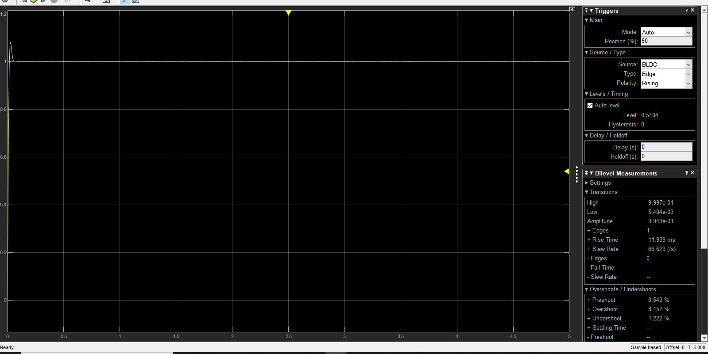

After PID tuning we got the rise time as 11.9ms and overshoot is 8.152% as the tuning made the system parameters to adjust accordingly to get the stable system.

2- Permanent Magnet Synchronous Motor with PID Controller:

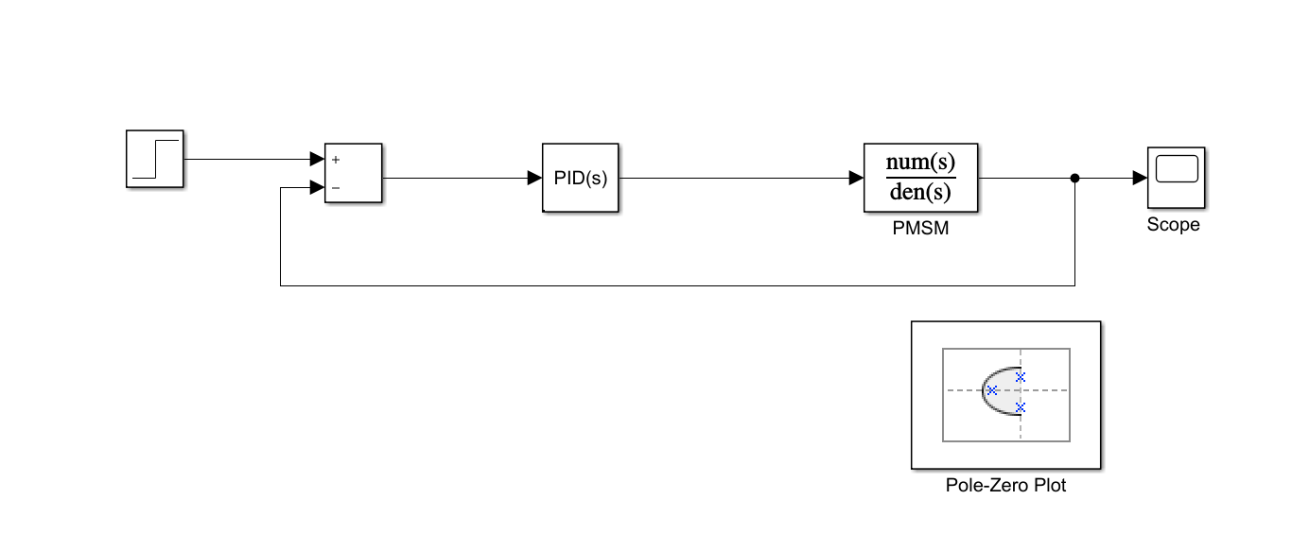

In this system, we will be analyzing the poles and zeros of the system when the PID controller is added to the system.

* We got 1 pair of complex conjugate pole, 1 pole pair on the horizontal axis and 3 zeroes.
* We got 3 poles and 2 zeroes on the left side of the imaginary axis and 1 pole and 1 zero on right side of the plane.

So, 2 zeroes and 2 poles will nullify their effect and 1 pole will be on the left side so that we can say that system is stable.

Pole-Zero map and Analysis:

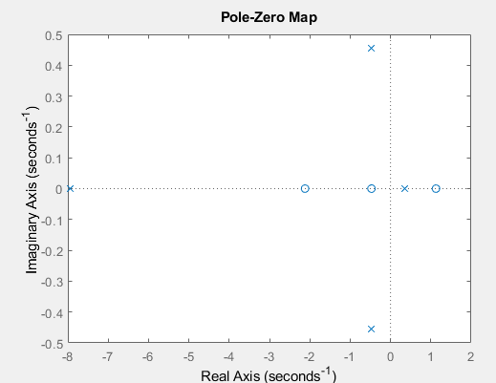

Poles of PMSM system:

-7.9492 + 0.0000i

-0.4733 + 0.4552i

-0.4733 - 0.4552i

0.3446 + 0.0000i

Zeroes of PMSM system:

-2.1189

1.1288

-0.4716

Output Graph:

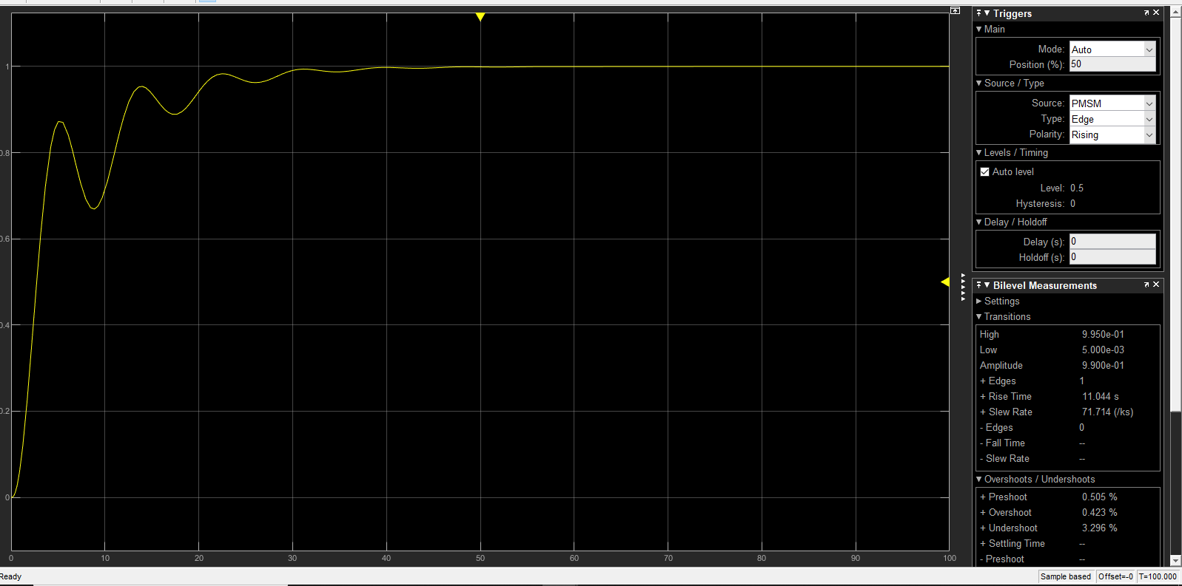

After PID tuning we got the rise time as 11.044ms and overshoot is 0.423% as the tuning made the system parameters to adjust accordingly to get the stable system.

3-Induction Motor with PID Controller:

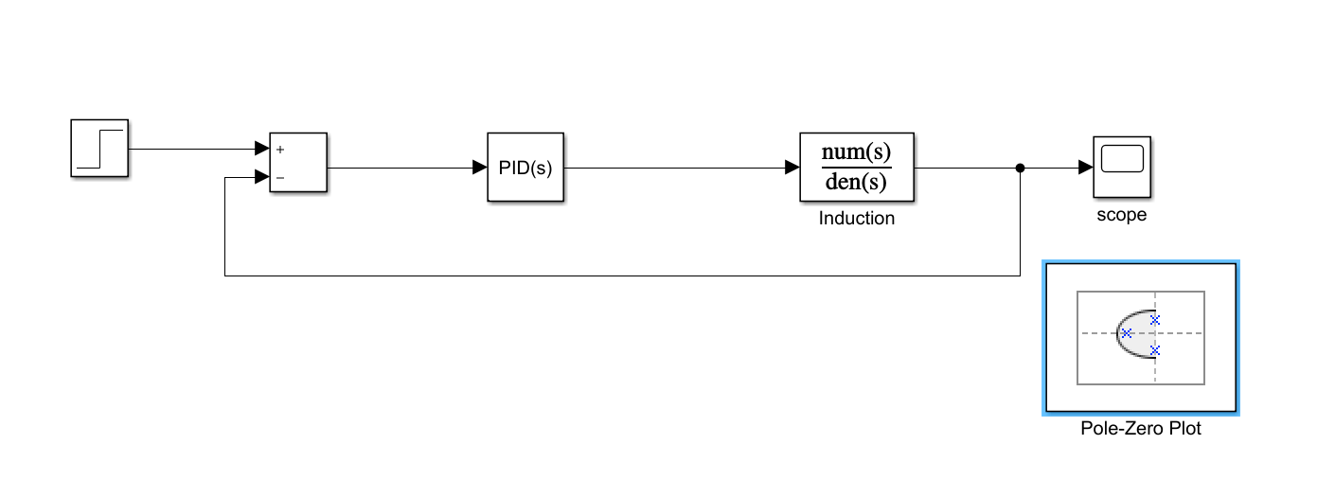

In this system, we will be analyzing the poles and zeros of the system when the PID controller is added to the system.

* We got 1 pair of complex conjugate pole, 1 pole pair on the horizontal axis and 2 zeroes.
* We got 3 poles and 2 zeroes on the left side of the imaginary axis

So, 2 zeroes and 2 poles will nullify their effect and 1 pole will be on the left side so that we can say that system is stable.

Pole-Zero Map and Analysis:

In this system, we will be analyzing the poles and zeros of the system when the PID controller is added to the system.

* We got 4 poles and 3 zeroes on the left side of the imaginary axis .

So, 3 zeroes and 3 poles will nullify their effect and 1 pole will be on the left side so that we can say that system is stable.

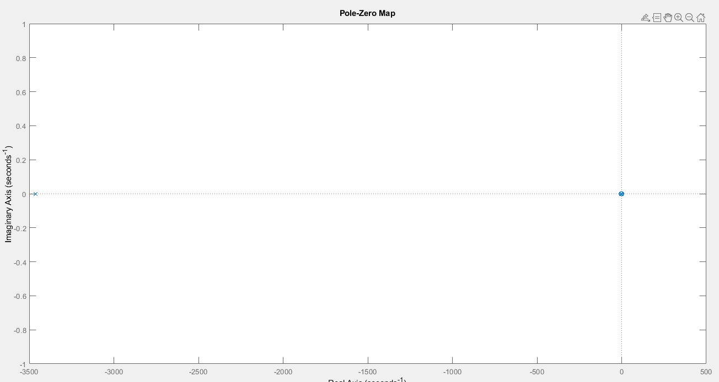

Poles of Induction Motor:

1.0e+03

-3.4615

-0.0023

0.0000

Zeroes of Induction Motor:

0

-2.7374

0.0118

Output Graph:

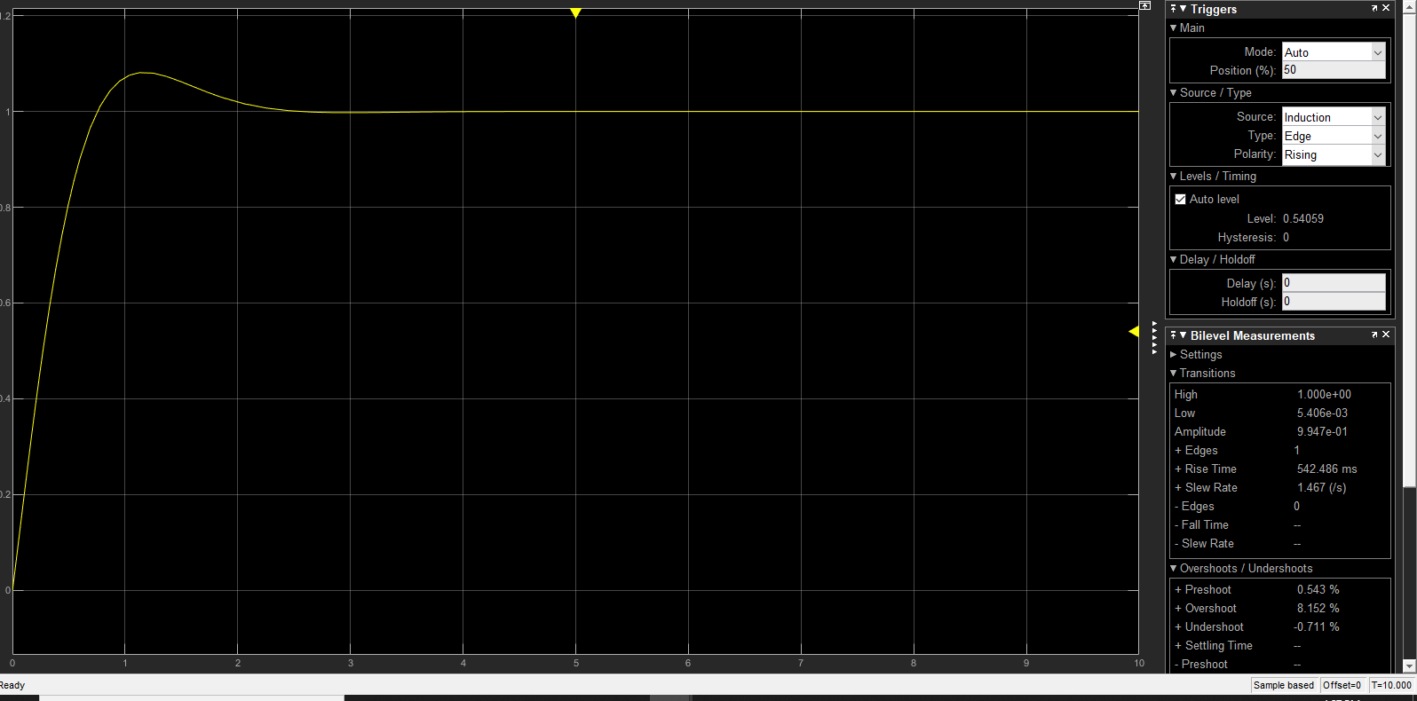

After PID tuning we got the rise time as 542.46ms and overshoot is 8.152% as the tuning made the system parameters to adjust accordingly to get the stable system.

4) PMSM Motor with PWM Controller:

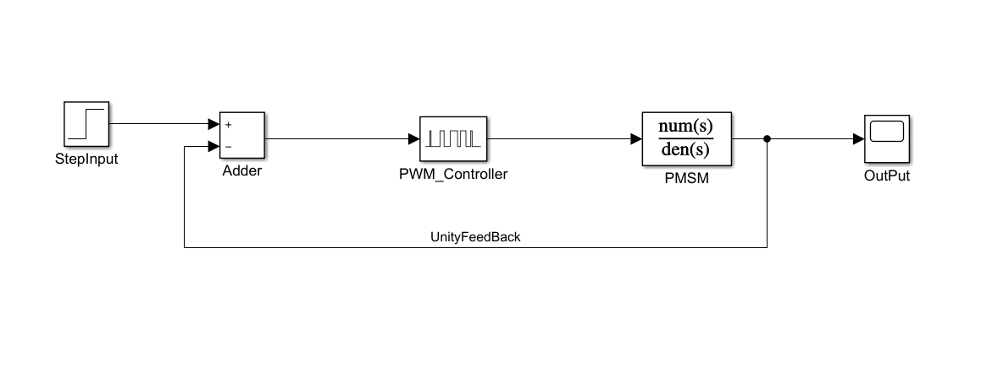

Output Graph:

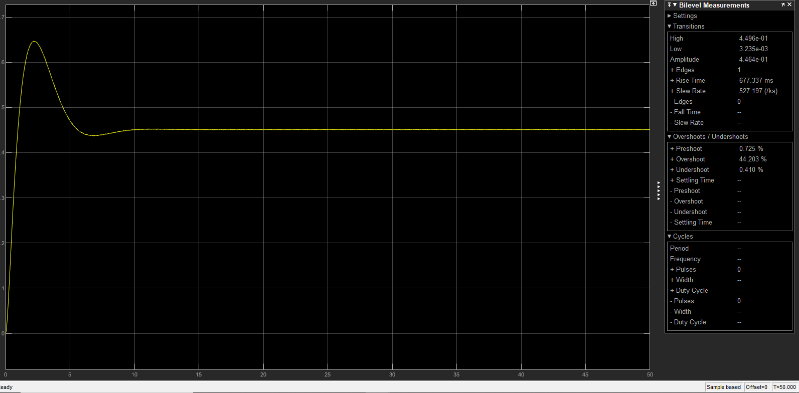

After PID tuning we got the rise time as 677.46ms and overshoot is 44% as the tuning made the system parameters to adjust accordingly to get the stable system.